EHS Portal - Phase 1 Design

# Executive Summary

The EHS (Environmental, Health & Safety) Portal is a web-based platform designed to replace scattered spreadsheets, emails, and paper forms with a single, structured system for managing safety incidents and inspections. Phase 1 delivers a focused, operational MVP that organizations can use immediately, while providing a foundation for more advanced capabilities in later phases.

**Phase 1 covers four core areas:**

Secure access & roles – Users authenticate with email and password, and are assigned one of three roles: Worker, Manager, or Admin. Each role sees only the functions and data they are allowed to use, ensuring clear separation of duties and controlled access to safety records.

Incident management – Workers and managers can record incidents with consistent mandatory fields (title, type, site, severity, date/time, description) and track them through a simple lifecycle from Open to Under Investigation to Closed.

Inspection management – Admins define reusable inspection templates; managers perform inspections using standardized checklists with OK / Not OK / N/A responses, and the system automatically calculates a Pass/Fail result.

Dashboard & KPIs – A homepage dashboard provides key safety metrics (incident and inspection counts, trends, and recent activity) so management can quickly understand current risk levels and where attention is needed.

From a technical perspective, Phase 1 consists of a modern React frontend, a Node.js/Express API, and a PostgreSQL database, with JWT-based authentication and role-aware navigation. The design has been specified in detail, implemented, and verified with automated tests and a structured UAT checklist. Together, these elements provide a robust baseline that can be extended in subsequent phases without rework of the core architecture.

# Introduction & Scope

The EHS (Environmental, Health & Safety) Portal Phase 1 delivers the Core Operational MVP for incident and inspection management, with an integrated dashboard that provides real-time visibility of safety performance. The purpose of this release is to move organizations away from scattered spreadsheets, emails, and paper forms, and into a single, structured web platform for capturing and monitoring safety events.

**Phase 1 focuses on four core capabilities:**

User authentication and role-based access – secure login with three roles (Worker, Manager, Admin) and clearly separated permissions.

Incident management – logging safety incidents with required details (title, type, site, severity, date/time, description), plus status tracking (Open → Under Investigation → Closed).

Inspection management – creating reusable inspection templates and performing inspections using standardized checklists with OK / Not OK / N/A outcomes.

Dashboard & reporting – surfacing key KPIs, charts, and recent activity so managers and executives can monitor safety performance at a glance.

Out of scope for Phase 1 are actions/CAPA, file attachments, audit logging, multi-organization tenancy, advanced analytics, and external notifications/integrations; these are planned for Phases 2–5. Phase 1 is intentionally scoped as a focused, operational foundation that can be deployed, used, and iterated on quickly, while leaving room for enterprise and integration features in later phases.

# Business Requirements (Phase 1)

Phase 1 business requirements are organized around four main areas: Incident Management, Inspection Management, Dashboard & Reporting, and User & Access Management. Together, they define the minimum capabilities needed for a usable, auditable EHS MVP.

**Incident Management**

Users must be able to create incident records with mandatory fields such as title, incident type, site, severity, date/time, and description (BR-INC-01, BR-INC-02).

Each incident is tied to a site and categorized by an incident type so that location-based and type-based reporting is possible.

Incidents follow a simple lifecycle: Open → Under Investigation → Closed, with status changes restricted to Managers and Admins, while Workers can only see and create incidents (BR-INC-03, BR-INC-04).

Workers see only incidents they have reported, whereas Managers and Admins have full visibility across the organization (BR-INC-05, BR-INC-06).

**Inspection Management**

Admins can configure inspection templates with a set of checklist items, including optional categories and ordering (BR-INSP-01, BR-INSP-02).

Managers can perform inspections by selecting a site and template; for each checklist item, they record OK, Not OK, or N/A, with optional comments (BR-INSP-03, BR-INSP-04).

The system automatically calculates the overall inspection result: FAIL if any item is Not OK, otherwise PASS, and stores full inspection history with item-level responses for audit and trend analysis (BR-INSP-05, BR-INSP-06).

**Dashboard & Reporting**

The dashboard must show five key KPIs: Total Incidents, Open Incidents, Incidents in the last 30 days, Inspections in the last 30 days, and Failed Inspections in the last 30 days (BR-DASH-01).

It must also provide an “incidents by type” chart to highlight patterns, and a severity trend over time to show whether safety performance is improving or degrading (BR-DASH-02, BR-DASH-03).

Recent incidents and inspections should be visible with click-through to details for quick follow-up (BR-DASH-04).

**User & Access Management**

Users authenticate with email and password; no self-registration is allowed in Phase 1. Accounts are created by Admins to ensure controlled onboarding and correct role assignment (BR-AUTH-01, BR-AUTH-05).

Three roles are supported: Worker, Manager, Admin. Admins manage sites, incident types, and inspection templates; Managers handle investigations and inspections; Workers report incidents and view their own records (BR-AUTH-02, BR-AUTH-03).

Passwords must be securely hashed and role-based access must be enforced consistently across the API and UI (BR-AUTH-04).

# Architecture Overview

See docs/ARCHITECTURE_PHASE1.md for full details.

Insert exported diagram from docs/ARCHITECTURE_PHASE1.md (diagram 1

Diagram 1 – System Context (Architecture diagram 1)

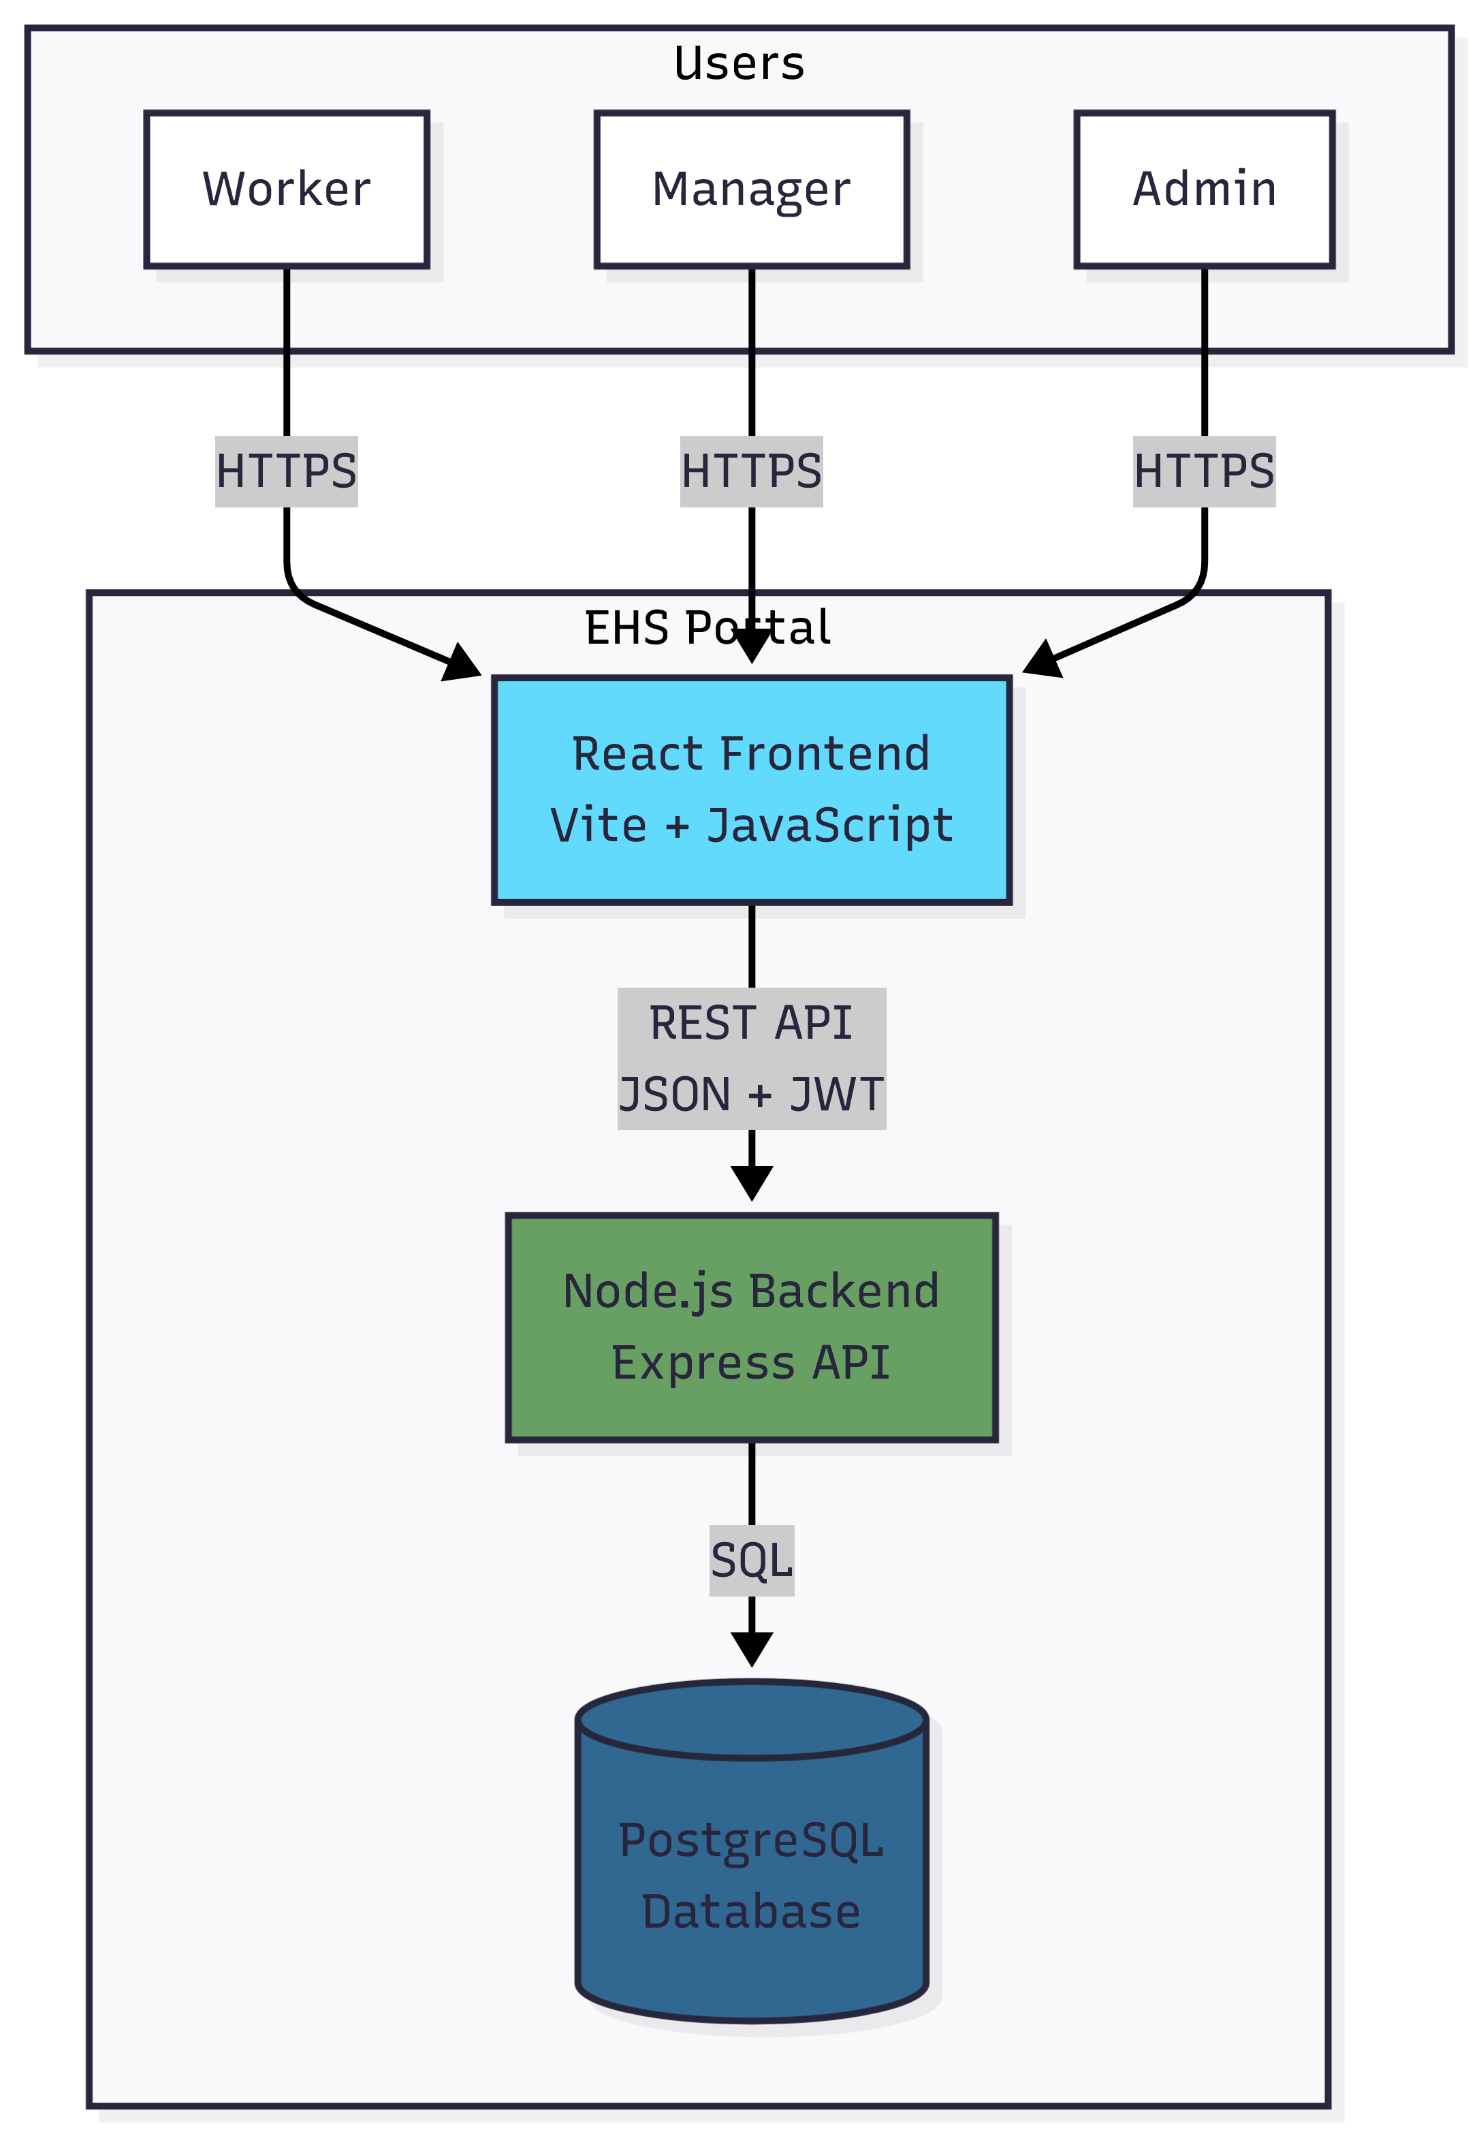

Insert exported diagram from docs/ARCHITECTURE_PHASE1.md (diagram 2)

Diagram 2 – Three-Tier Architecture (Architecture diagram 2)

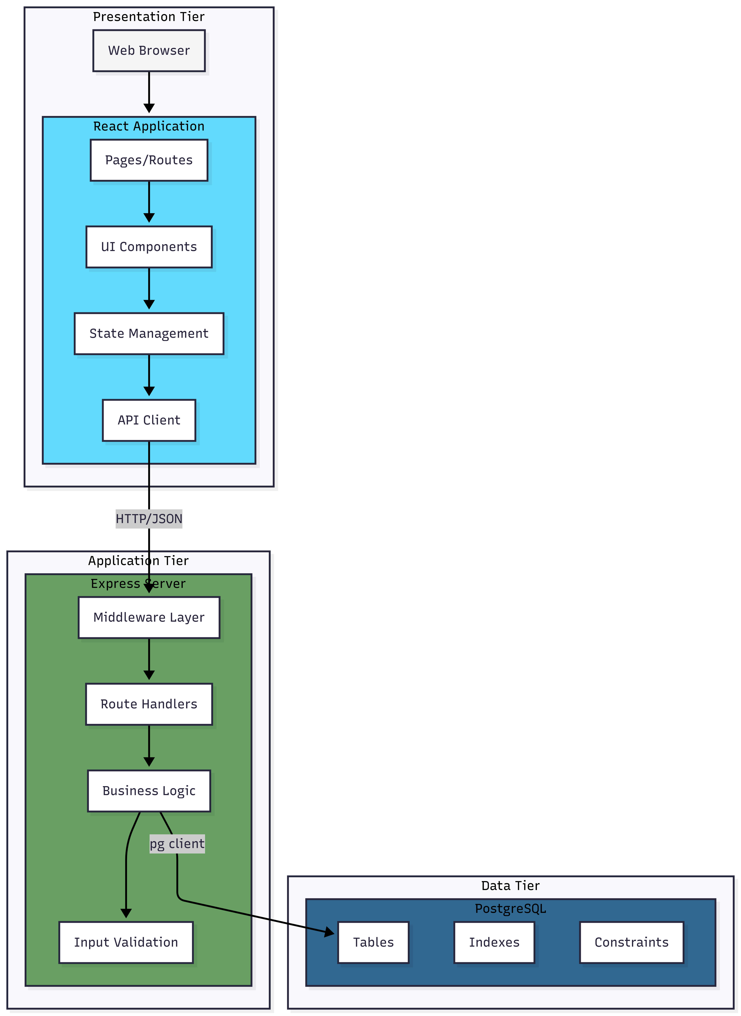

Insert exported diagram from docs/ARCHITECTURE_PHASE1.md (diagram 3)

Diagram 3 – Frontend Component Structure (Architecture diagram 3)

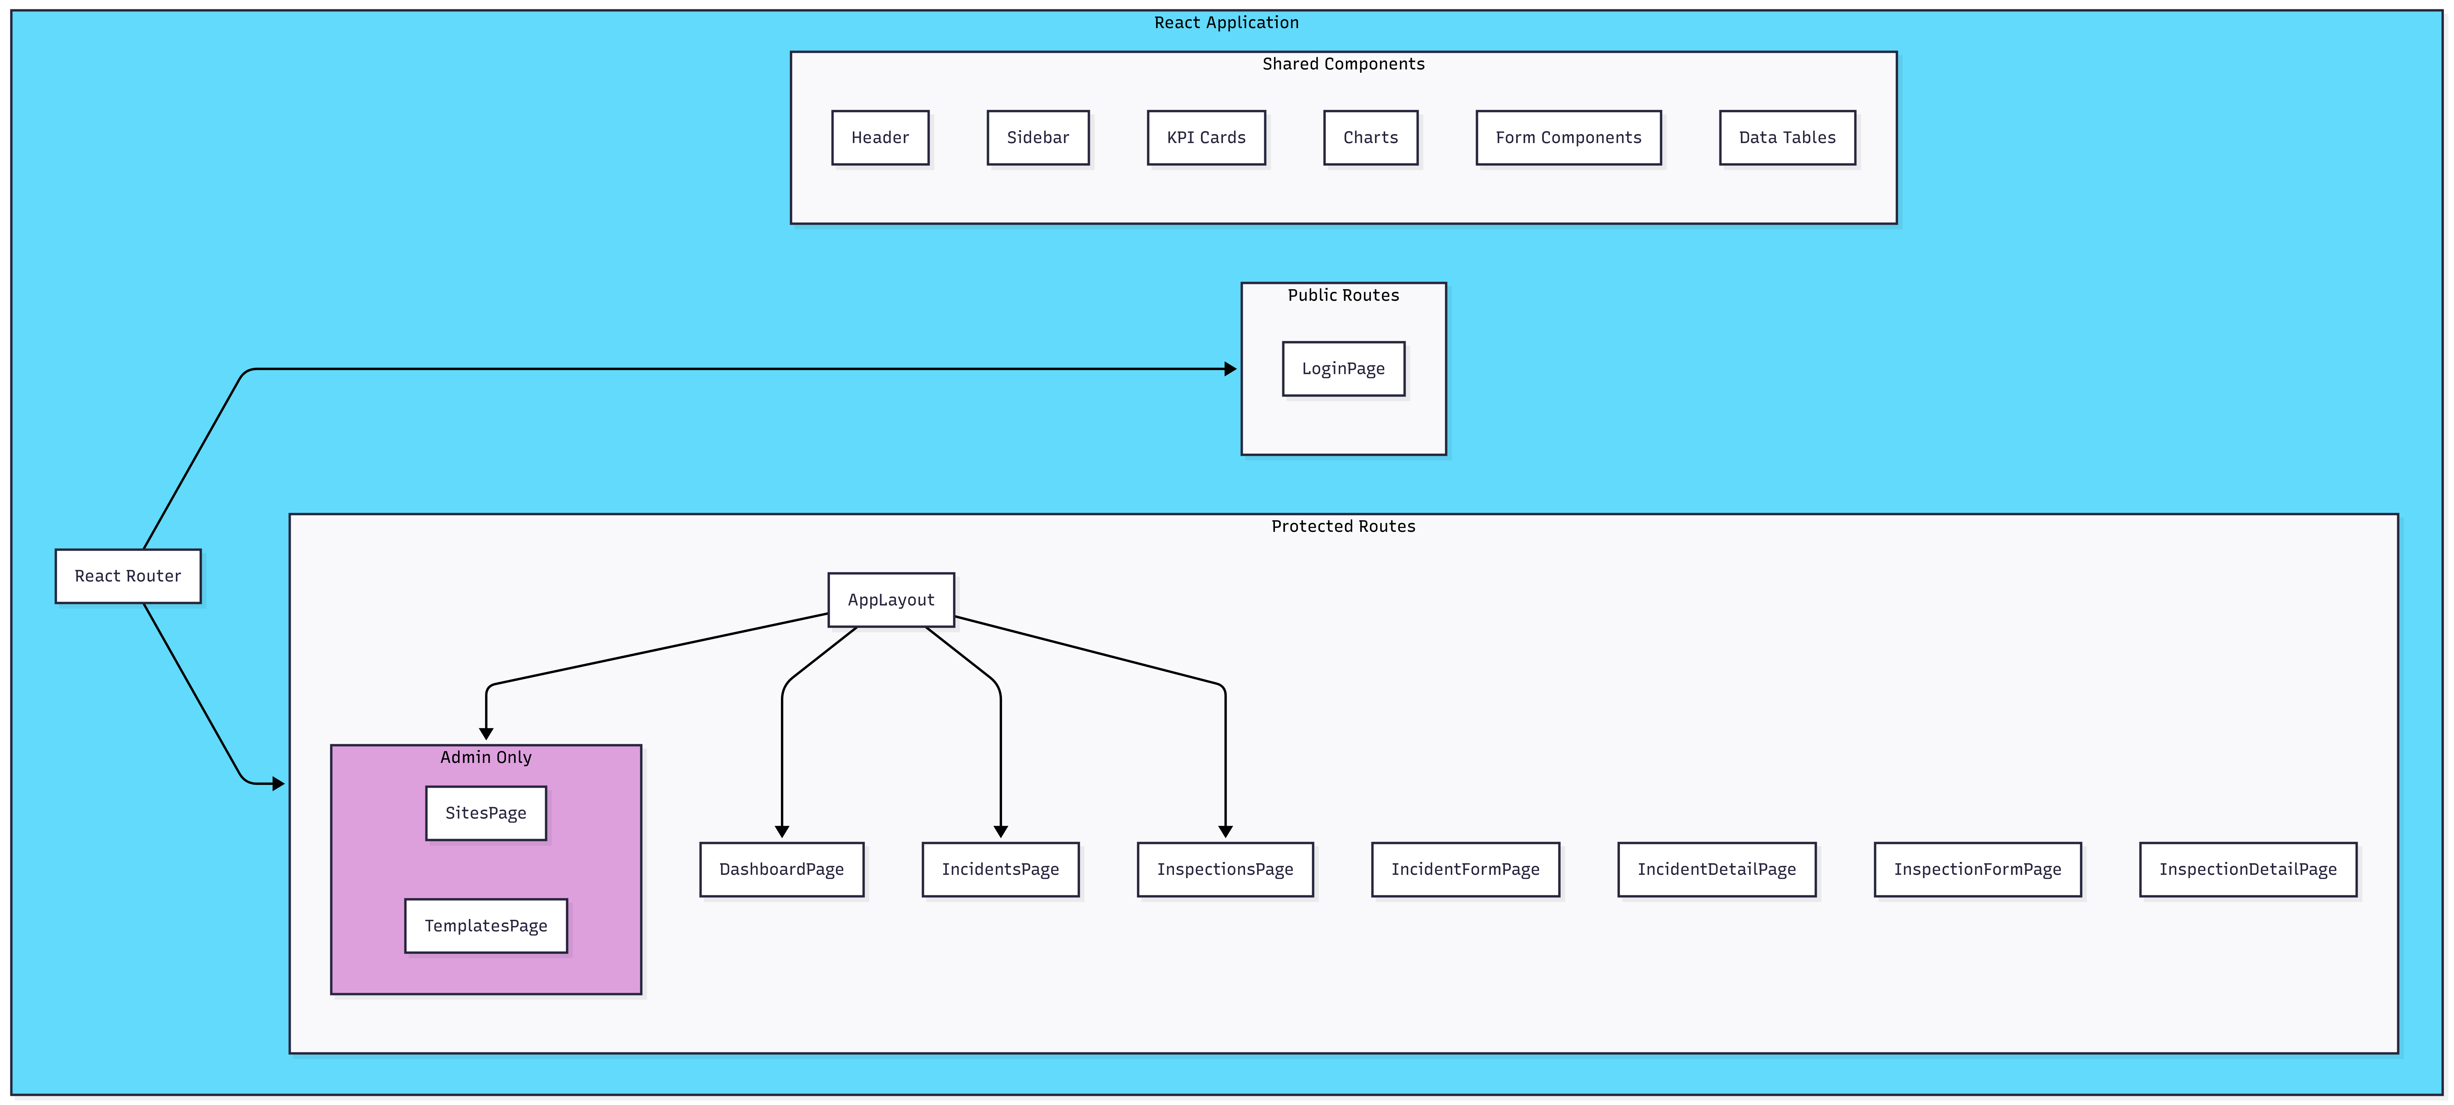

Insert exported diagram from docs/ARCHITECTURE_PHASE1.md (diagram 4) PNG/SVG from Mermaid here.

Diagram 4 – Backend Component Structure (Architecture diagram 4)



Insert exported diagram from docs/ARCHITECTURE_PHASE1.md (diagram 5)

Diagram 5 – Authentication Flow (Architecture diagram 5)

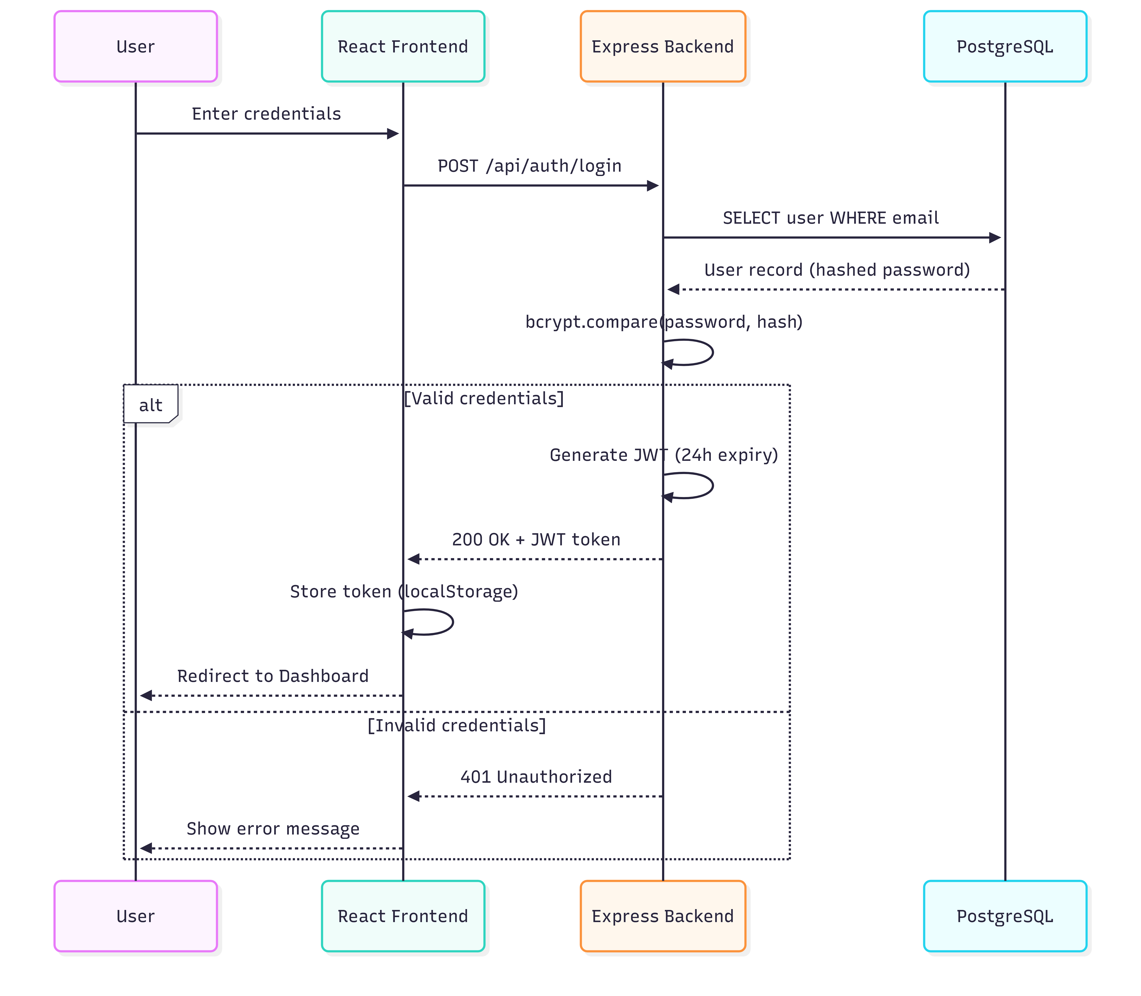

Insert exported diagram from docs/ARCHITECTURE_PHASE1.md (diagram 6)

Diagram 6 – Authorization Model (Architecture diagram 6)

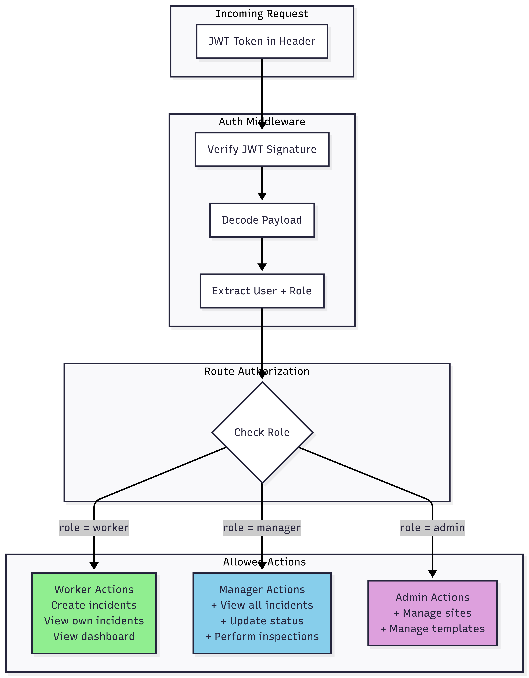

Insert exported diagram from docs/ARCHITECTURE_PHASE1.md (diagram 7

Diagram 7 – RESTful API Structure (Architecture diagram 7)

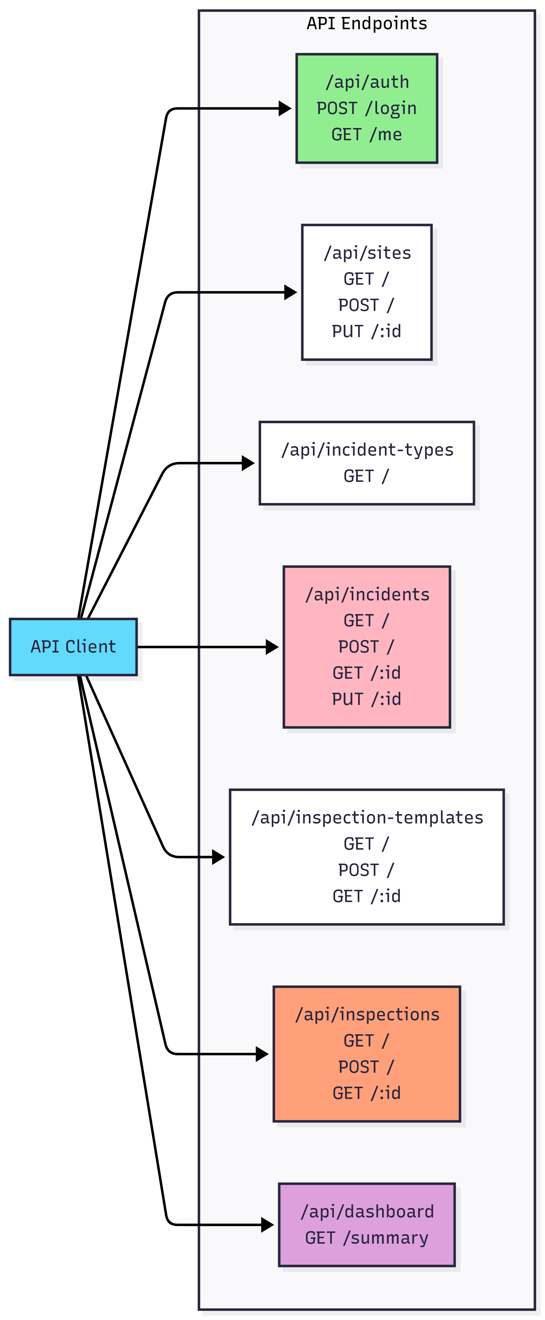

Insert exported diagram from docs/ARCHITECTURE_PHASE1.md (diagram 8)

Diagram 8 – Request/Response Flow (Architecture diagram 8)

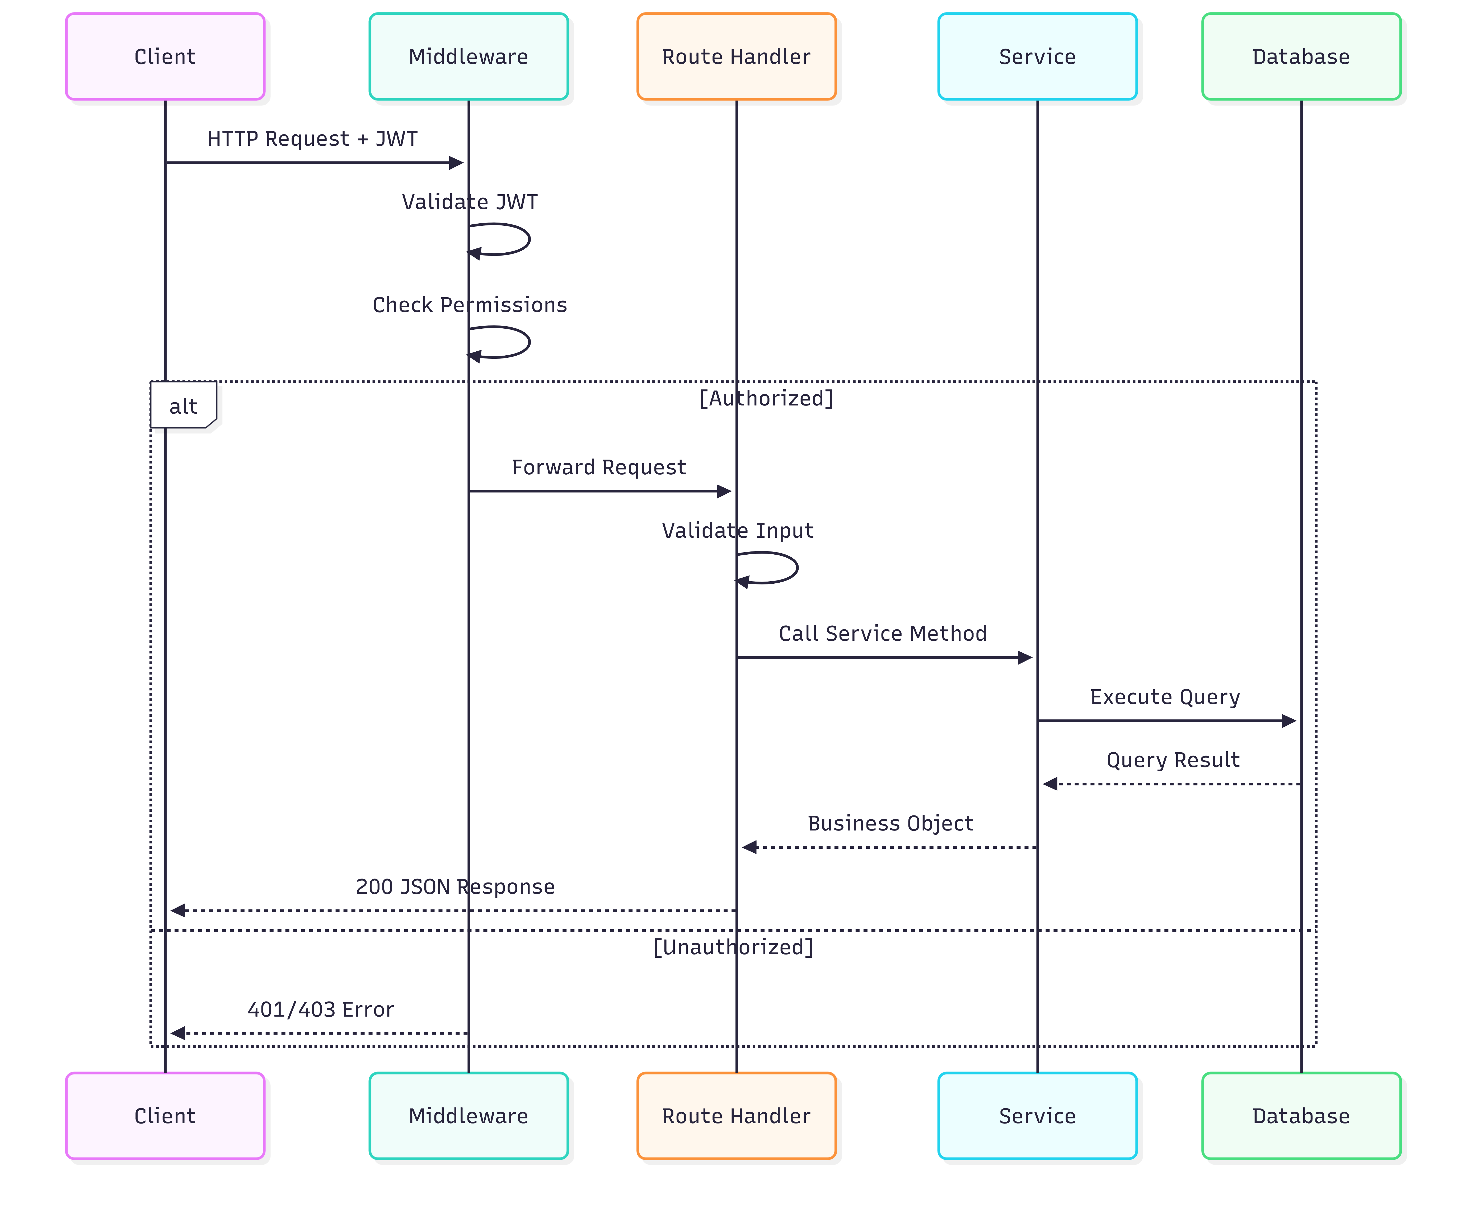

Insert exported diagram from docs/ARCHITECTURE_PHASE1.md (diagram 9)

Diagram 9 – Development Environment (Architecture diagram 9)

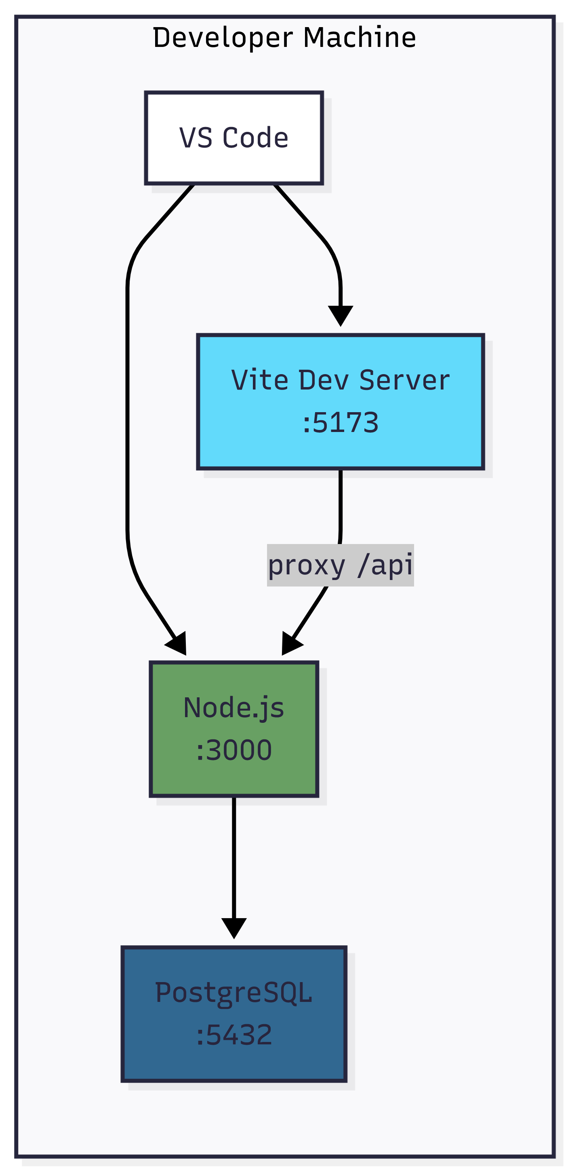

Insert exported diagram from docs/ARCHITECTURE_PHASE1.md (diagram 10)

Diagram 10 – Production Deployment (Architecture diagram 10)

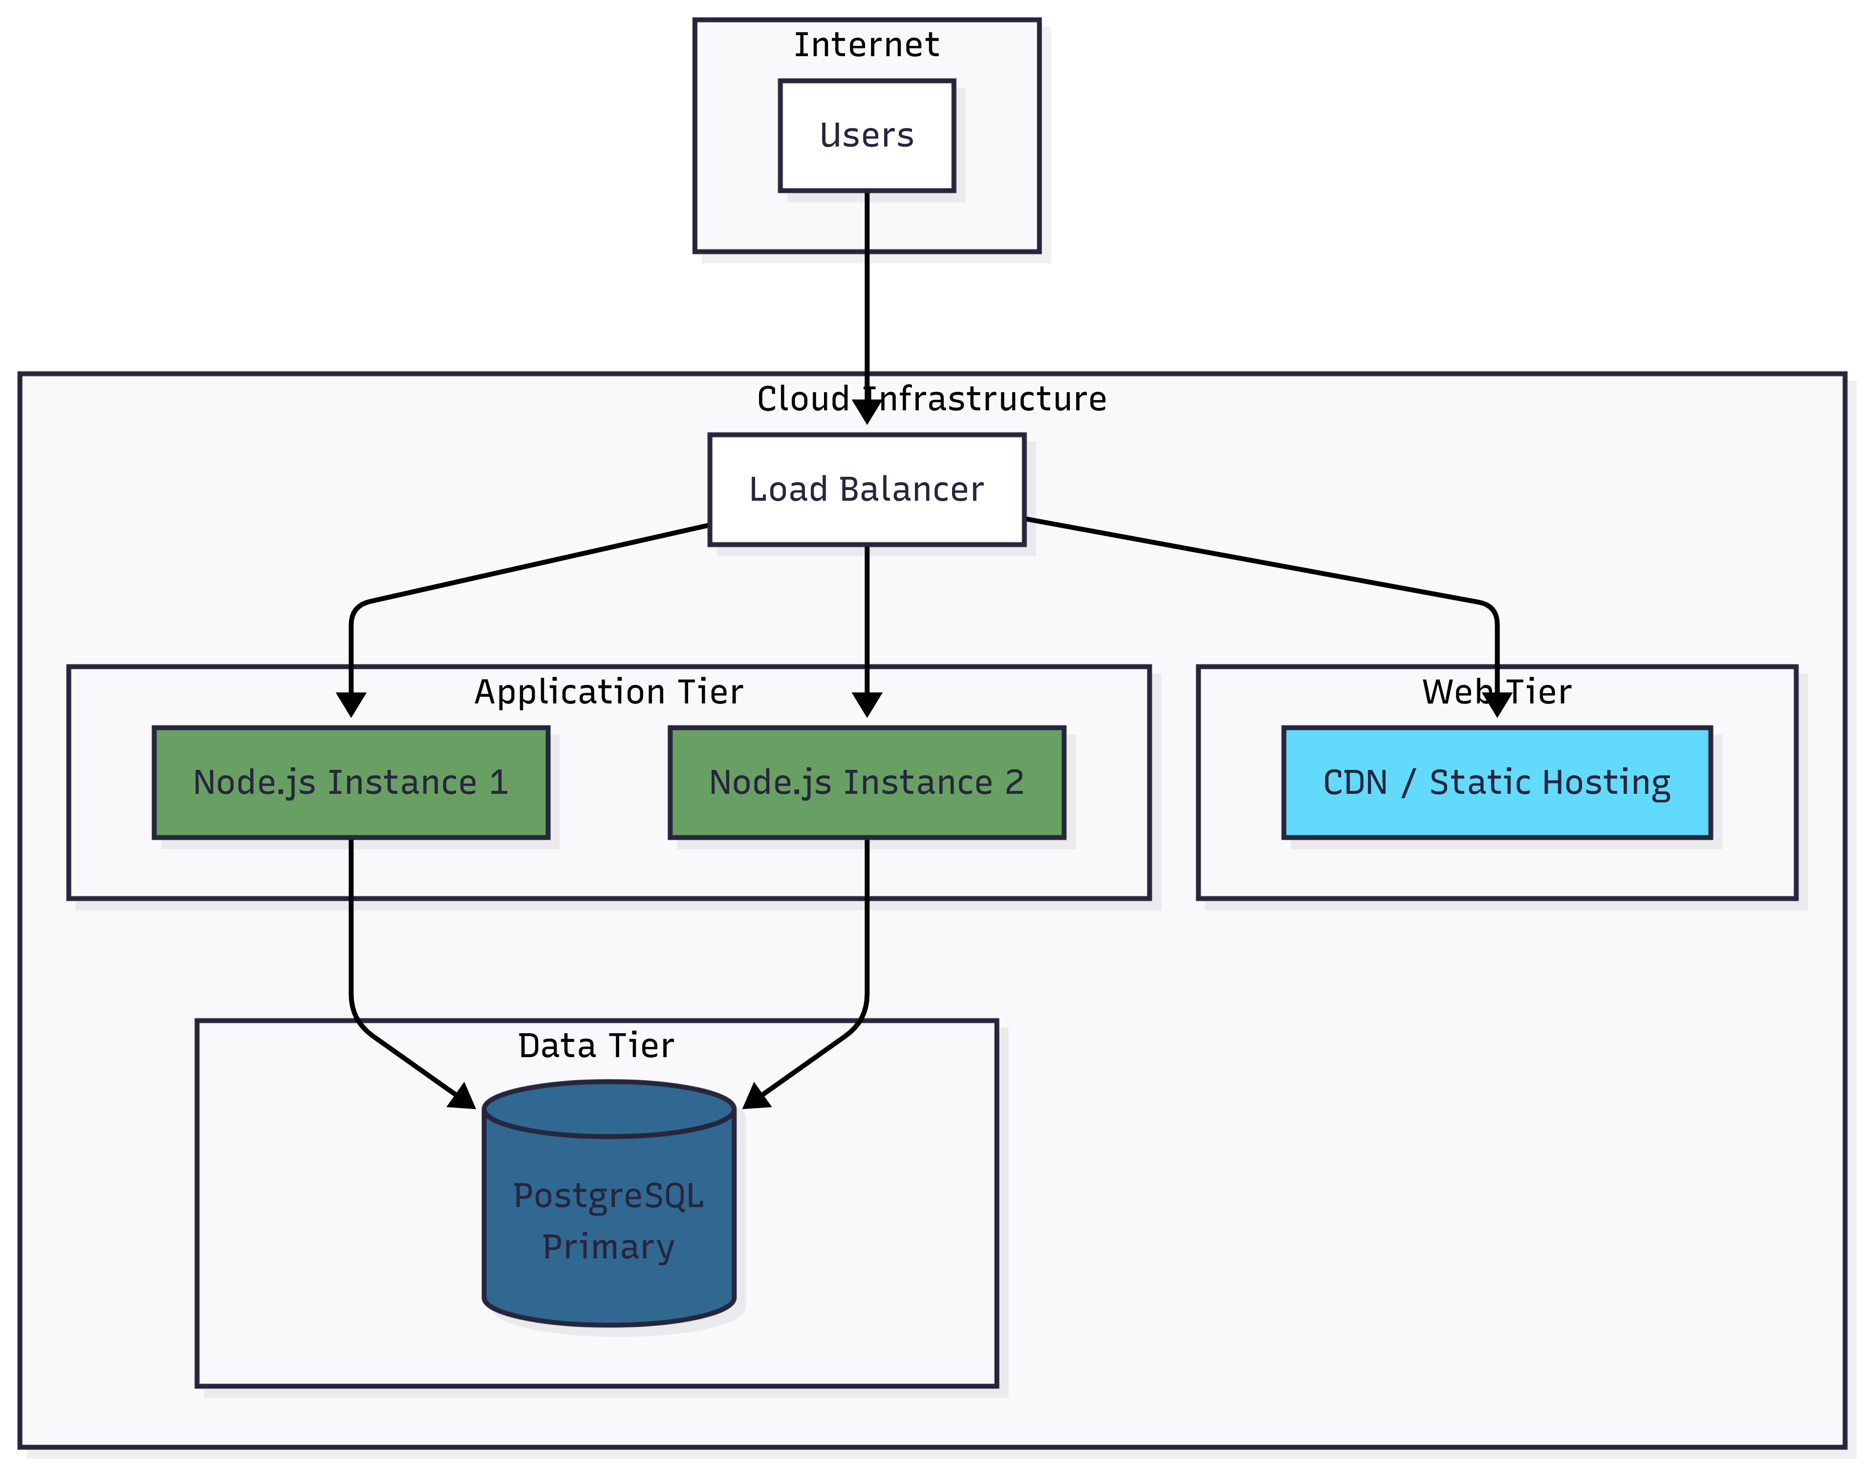

# Data Model (ERD)

See docs/DATA_MODEL_PHASE1.md for full details.

Insert exported diagram from docs/DATA_MODEL_PHASE1.md (diagram 1)

2.1 Complete Phase 1 ERD

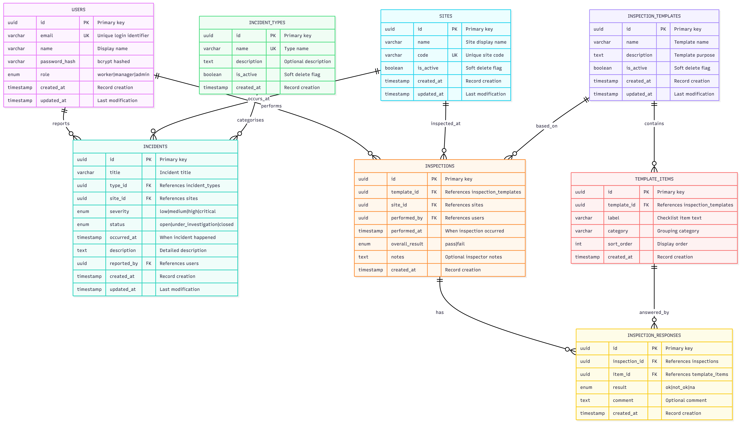

Insert exported diagram from docs/DATA_MODEL_PHASE1.md (diagram 2)

4.1 Relationship Summary

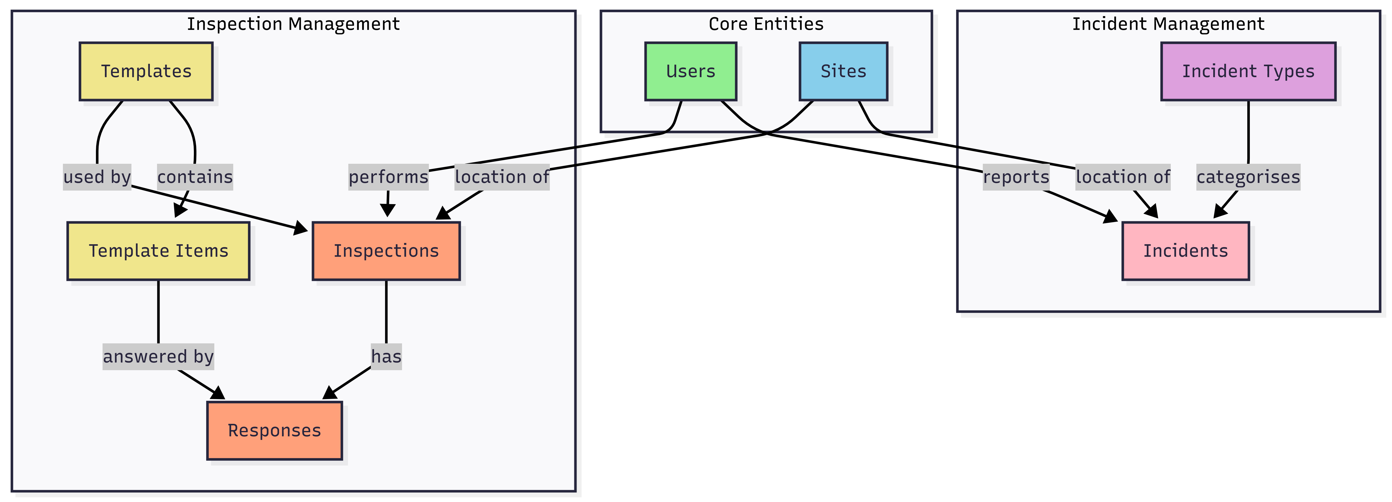

# Key Workflows

See docs/WORKFLOWS_PHASE1.md for full details.

Insert exported diagram from docs/WORKFLOWS_PHASE1.md (diagram 1)

User Login Flow

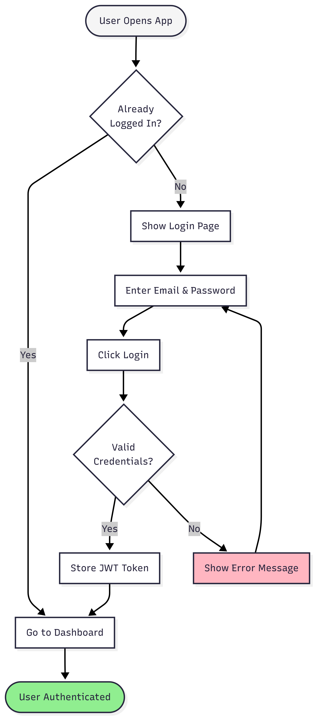

Insert exported diagram from docs/WORKFLOWS_PHASE1.md (diagram 2)

Create Incident Flow

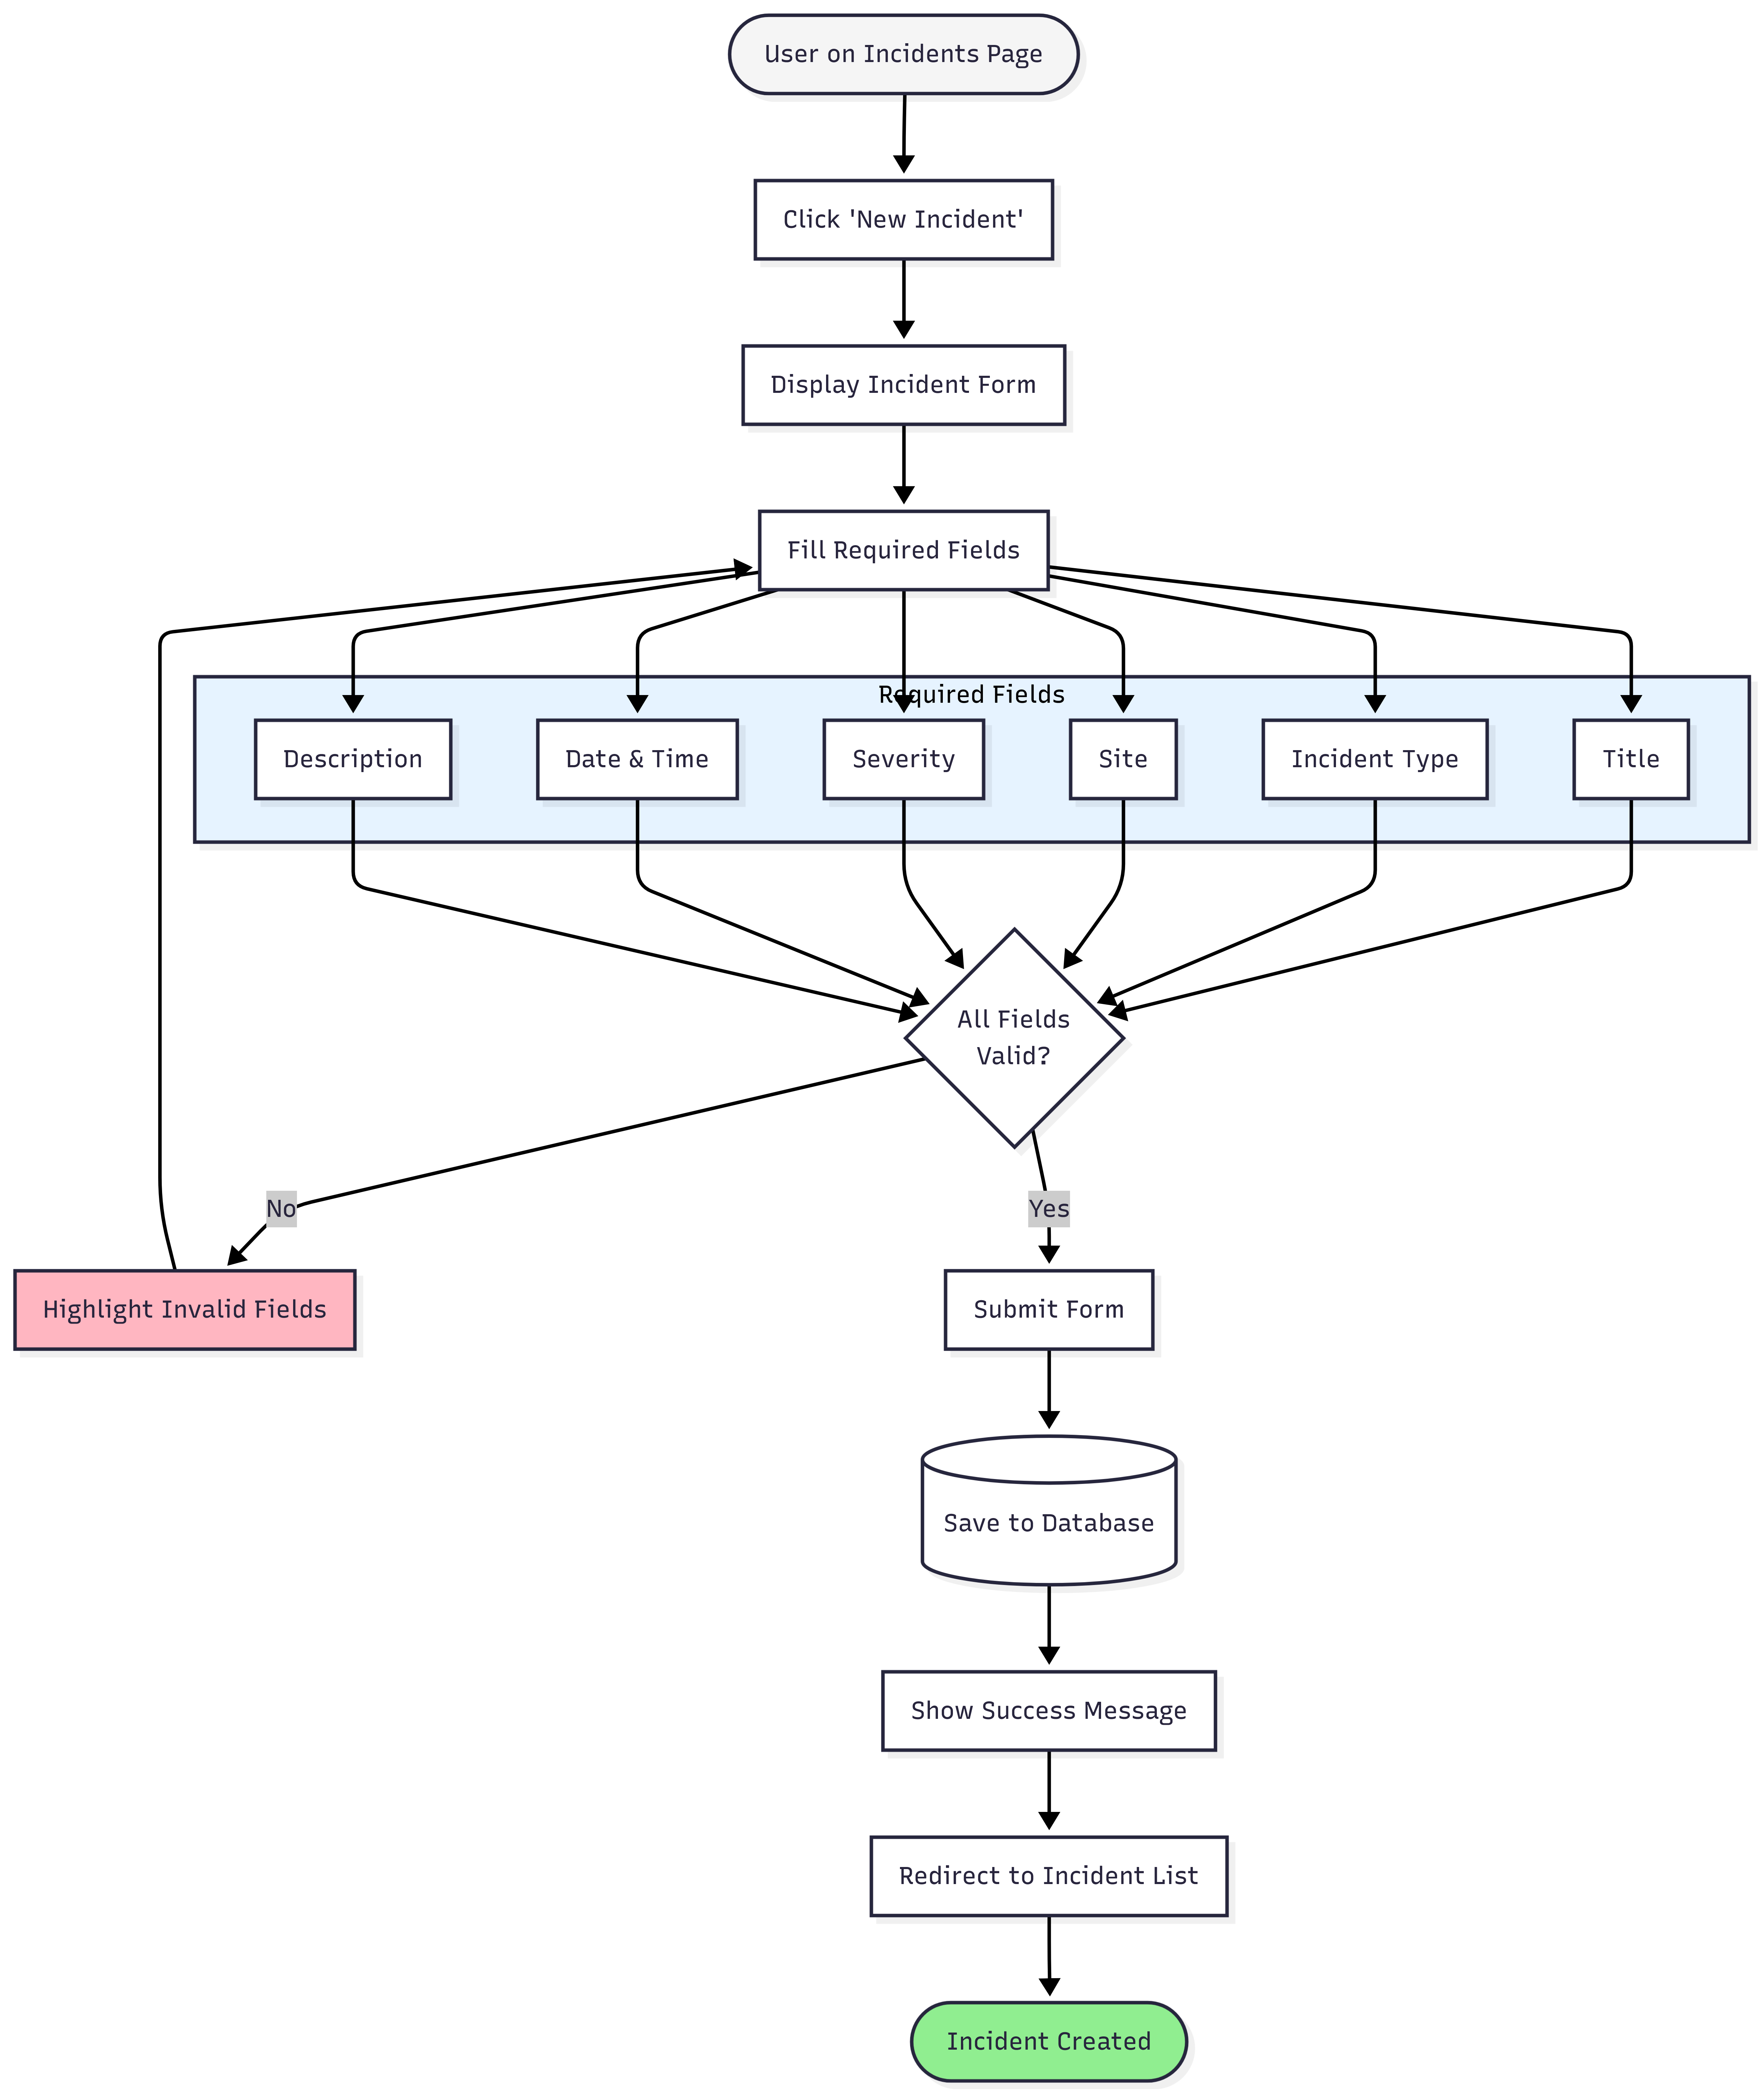

Insert exported diagram from docs/WORKFLOWS_PHASE1.md (diagram 3)

Perform Inspection Flow

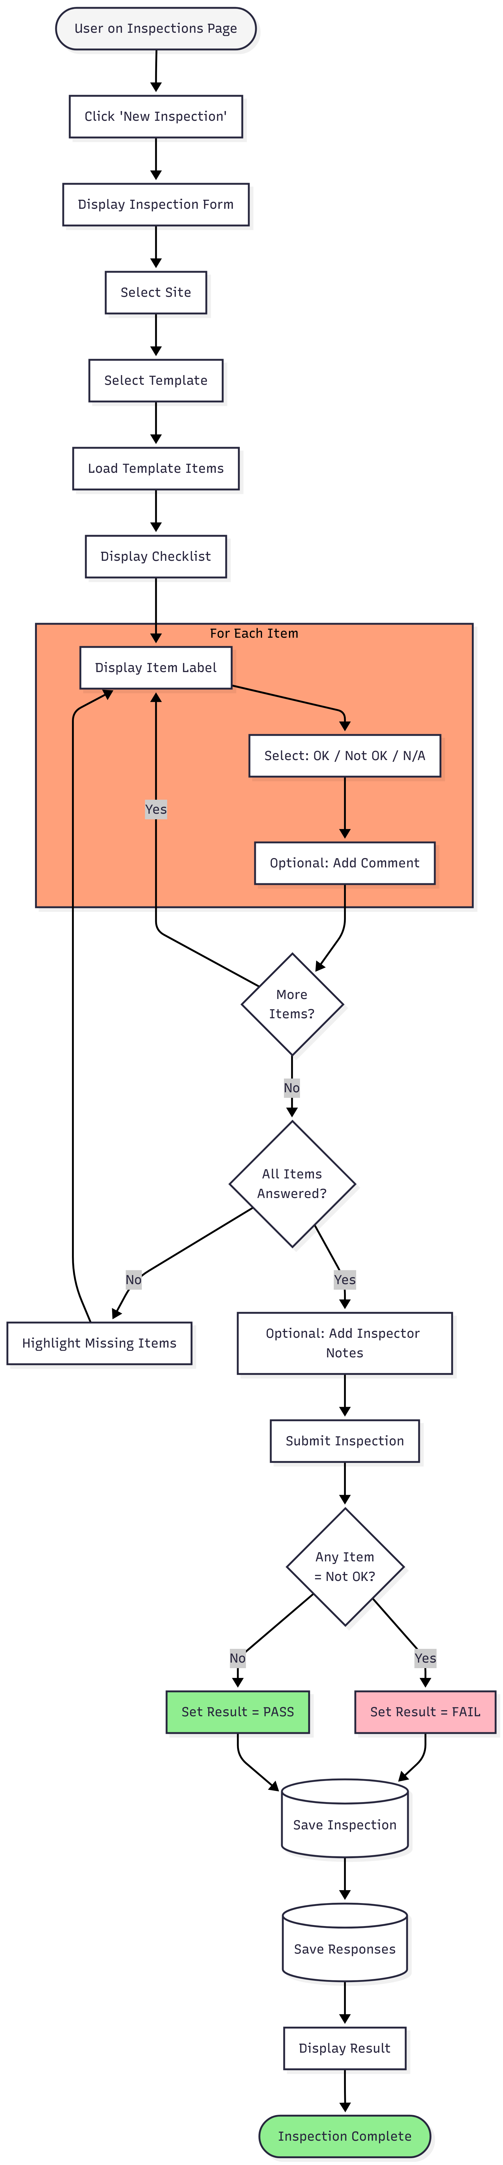

Insert exported diagram from docs/WORKFLOWS_PHASE1.md (diagram 4

View Dashboard Flow



Insert exported diagram from docs/WORKFLOWS_PHASE1.md (diagram 5)

One journey diagram (e.g. Worker Journey)

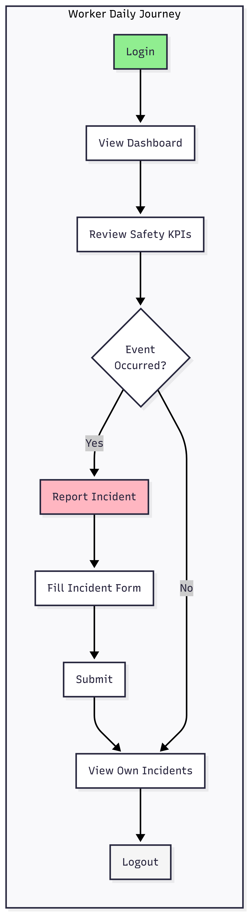

# API Summary

# API Summary (Phase 1)

The Phase 1 backend exposes a RESTful API under the base URL http://localhost:3001/api, using JSON payloads and JWT-based authentication. All endpoints (except login) require an Authorization: Bearer <jwt_token> header, and return errors in a consistent { "error": "...", "code": "..." } format with standard HTTP status codes.

Authentication & Session

POST /api/auth/login authenticates a user by email and password and returns a JWT plus basic user profile (id, email, firstName, lastName, role).

GET /api/auth/me returns the current authenticated user based on the supplied token. Self-registration is not available in Phase 1; users are provisioned by Admins outside of these endpoints.

Sites & Reference Data

GET /api/sites lists all sites; POST /api/sites and PUT /api/sites/:id allow Admins to create and update site records, enforcing unique site codes and role-based permissions.

GET /api/incident-types returns all incident types used for classification; POST /api/incident-types, PUT /api/incident-types/:id, and PATCH /api/incident-types/:id let Admins configure the catalogue of incident types, including activation/deactivation, fulfilling the “configurable by admin” requirement for incident types.

Incident Management API

GET /api/incidents lists incidents, with optional filters for status and site. Workers see only incidents they reported; Managers and Admins see all incidents.

GET /api/incidents/:id returns full incident details including type, site, reporter, severity, and current status.

POST /api/incidents creates a new incident with validation on required fields and allowed severity values. Status is initialised to open, and reported_by is set to the authenticated user.

PUT /api/incidents/:id supports updating incident fields; in particular, status changes (e.g. open → under_investigation → closed) are controlled and restricted to Manager/Admin roles.

Inspection Templates & Inspections API

GET /api/inspection-templates lists available templates; GET /api/inspection-templates/:id provides a template plus its checklist items.

POST /api/inspection-templates and PUT /api/inspection-templates/:id allow Admins to create and update templates and their items in a single payload, ensuring the UI can render structured checklists.

GET /api/inspections lists inspections with optional filters (site, template, pass/fail).

GET /api/inspections/:id returns an inspection with its responses, including item-level details and comments.

POST /api/inspections creates an inspection and associated responses. The backend validates that responses match the template items and computes overallResult based on whether any item result is not_ok.

Dashboard API

GET /api/dashboard/summary aggregates data for the dashboard:

KPI counts (total incidents, open incidents, incidents last 30 days, inspections last 30 days, failed inspections last 30 days)

Incidents by type

Severity trend over time

Recent incidents and inspections for quick drilling into details.

# Each endpoint is mapped back to Phase 1 checklist IDs to maintain traceability (e.g. C35/C36 for auth, C1–C5 for incidents, C8–C15 for inspections, C47–C55 for dashboard), ensuring that the implemented API surface directly supports the agreed business requirements and compliance checklist.

# Test Strategy (Phase 1)

**Test Strategy (Phase 1)**

The Phase 1 test strategy follows **shift-left**, **ATDD (Acceptance Test-Driven Development)**, and **TDD (Test-Driven Development)** principles to ensure quality is built in from requirements through to implementation. Testing starts at the design stage, with testers and the BA reviewing user journeys, data model, and API design for clarity and testability. Acceptance tests for key user stories are defined up front in business language, then mapped to concrete test cases (TC-IDs) before coding begins.

**Scope & Levels of Testing**  
For Phase 1, the focus is on the core flows: authentication, incident lifecycle, inspection lifecycle, and dashboard reporting. The following test layers are applied:

* **Unit tests** for critical business logic (e.g. inspection overall result calculation, dashboard aggregation helpers).
* **Integration/API tests** for all main endpoints: login, sites, incident types, incidents CRUD, inspection templates, inspections, and dashboard summary.
* **UI/Frontend tests** for core journeys (login, create incident, create inspection) plus manual smoke tests across all major screens (P1-J1 to P1-J7).
* **Light non-functional checks** for basic performance, security (auth/rbac), and usability.

**ATDD & Traceability**  
For each important user story (e.g. “Worker logs an incident”, “Manager performs an inspection”), a set of acceptance tests is documented from the user’s perspective (Given/When/Then) and linked to:

* Phase 1 checklist items (C-IDs),
* User stories (US-IDs), and
* Concrete test cases (TC-IDs, such as TC-INC-01, TC-INSP-04, TC-DASH-02).  
  This creates a clear chain from requirement → story → test case → implementation, and allows quick coverage checks before sign-off.

**Execution & Quality Gates**

* Backend: Jest tests cover auth, sites, incident types, incidents, inspection templates, inspections, and dashboard, using a dedicated test database with seeded users, sites, and reference data.
* Frontend: tests verify that login works, that incidents and inspections can be created via the UI, and that screens render as expected for key flows; manual UAT uses scripted checklists to validate behavior end-to-end.

Phase 1 exit criteria are:

* All **Phase 1 must-have** checklist items have at least one acceptance test and corresponding test case.
* All planned Phase 1 tests are executed and passing (no Critical/High defects open in core flows).
* UAT sign-off from business stakeholders confirms that the MVP behaves correctly for the essential worker, manager, and admin journeys.

# Conclusion & Next Phases

Phase 1 of the EHS Portal establishes a solid, working foundation for digital safety management:

- The core workflows for logging incidents, performing inspections, and reviewing KPIs are implemented end-to-end.

- Role-based access control ensures that Workers, Managers, and Admins each see the right functionality and data for their responsibilities.

- The underlying architecture (React frontend, Node.js/Express backend, PostgreSQL data model) has been designed and implemented in a way that supports scaling and future enhancements.

- Automated tests and a defined UAT checklist give confidence that the most important flows behave as expected and can be re-tested quickly when changes are made.

This means the organization can already start using the system for real-world incident and inspection capture, while planning the next wave of capabilities.

Roadmap: Future Phases (High Level)

Subsequent phases are expected to build on this foundation along the following lines:

- Phase 2 – Actions & Operational Excellence

- Introduce actions/CAPA linked to incidents and inspections.

- Add evidence/attachments, RBAC hardening, and basic audit logging.

- Provide in-app help to support end users.

- Phase 3 – Multi-Organization & Exports

- Add multi-organization support (separate data per client or business unit).

- Provide CSV/Excel exports for incidents, inspections, and actions.

- Phase 4 – Analytics & Risk

- Deliver richer analytics dashboards (trends, hotspots, benchmarks).

- Introduce a risk register and basic risk assessment capabilities.

- Phase 5 – Notifications & Integrations

- Add email/chat notifications for key events and overdue actions.

- Provide integration points (APIs/webhooks/SSO) so the EHS Portal can connect to other systems.

Each phase will follow the same disciplined approach used for Phase 1: clear business requirements, detailed architecture and data modelling, API and UX specifications, and a test strategy with traceable test cases. This ensures that the solution grows in a controlled way while remaining understandable, supportable, and audit-ready.

In summary, Phase 1 is not a prototype: it is a deployable, supportable MVP that already delivers meaningful value for safety teams, while setting a clear and structured path for future enhancements.